**HLSC 2310: Calculating Energy Requirements**

Name: ­­­­­­­­­­­­­__________________ID:_______________

**CALCULATIONS:**

1. Textbook

**Men:**

BMR = kg body weight x 24

EER = BMR + (BMR x %AL)

**Women:**

BMR = kg body weight x 22

EER = BMR + (BMR x %AL)

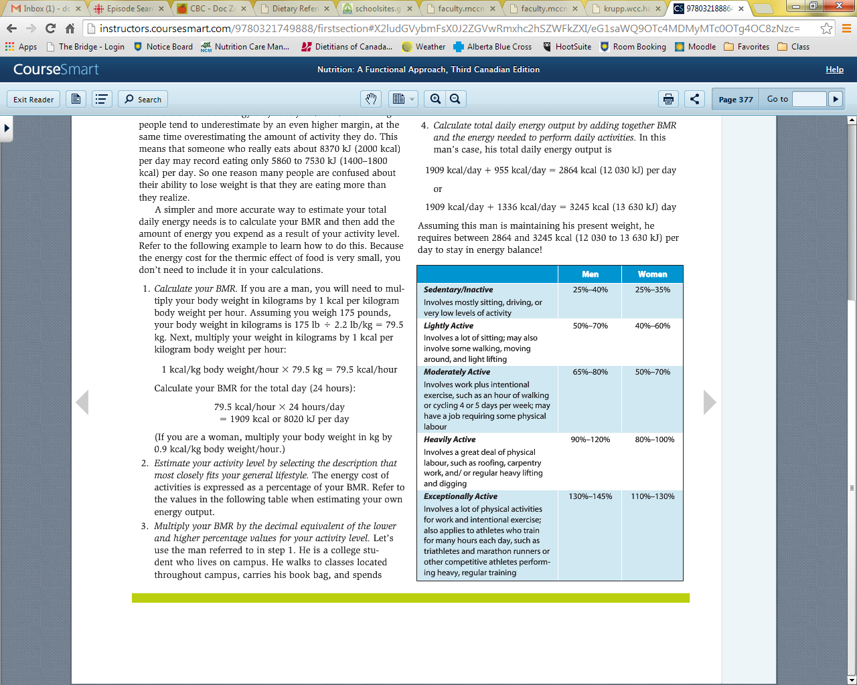**Activity Levels (%AL)**

1. Health Canada

**Men: 19 years and older**

EER = 662 – (9.53 x age) + PA x [(15.91 x wt) + (539.6 x ht)]

**Women: 19 years and older**

EER = 354 – (6.91 x age) + PA x [(9.36 x wt) + (726 x ht)]

**Note:** Wt and Ht are in Kg and m.

Physical Activity Coefficients (PA values) for use in EER equations

|  |  |  |  |  |  |
| --- | --- | --- | --- | --- | --- |
|  | **Sedentary** | **Low Active** | **Active** | **Very Active** |  |
|  | Typical daily living  activities  (e.g., household tasks, walking to the bus) | Typical daily living  activities PLUS  30 - 60 minutes of daily moderate activity  (ex. walking at 5-7 km/h) | Typical daily living  activities PLUS  At least 60 minutes of daily moderate activity | Typical daily living activities  PLUS  At least 60 minutes of daily moderate activity  PLUS  An additional 60 minutes of vigorous activity or 120 minutes of moderate activity |  |
| Boys 3 - 18 y | 1.00 | 1.13 | 1.26 | 1.42 | |
| Girls 3 - 18 y | 1.00 | 1.16 | 1.31 | 1.56 | |
|  |  |  |  |  | |
| Men 19 y + | 1.00 | 1.11 | 1.25 | 1.48 | |
| Women 19 y + | 1.00 | 1.12 | 1.27 | 1.45 | |

Conversions

1. Convert height from inches into meters (remember that each “foot” of height is equivalent to 12 inches so if a person is 5’ 10” tall, they height are 70 inches)

Divide height in inches by 39.37 to find height in meters

Ex.) 70 inches ÷ 39.37 inches/meter = 1.78 meters (rounded off)

1. Convert weight from pounds into kilograms

Divide weight in pounds by 2.2 to find weight in kilograms

Ex.) 175 pounds ÷ 2.2 = 79.55 kg (rounded off)

Using BOTH of the above calculations, calculate the energy requirements for the following scenarios. SHOW YOUR WORK!

1. Gender: Male

Age: 34

Height: 6’ 2” = **1.828m**

Weight: 214 lb = **97.27 kg**

Activity: Goes to gym 4 times/week for 60 minutes, moderate intensity and walks dog for 30 minutes daily. **PA: 1.11, AL: .65-.80**

1. Gender: Female

Age: 23

Height: 5’ 6”

Weight: 165 lb

Activity: Walks to and from school 5 days/week for 60 minutes total

5’6’’ = 1.70m

74.84kg

1. Gender: Female

Age: 29

Height: 5’ 8”

Weight: 143 lb

Activity: Runs daily for 60 minutes, goes to gym 3 times/week for 30 minutes, low intensity

1. Gender: Male

Age: 21

Height: 6’ 0”

Weight: 178 lb

Activity: Bikes to and from work 5 days/week for 20 minutes total